OData – Transaction SEGW

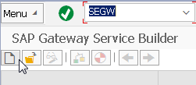

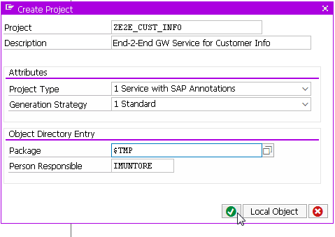`

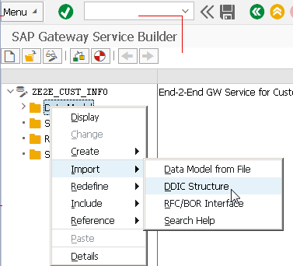

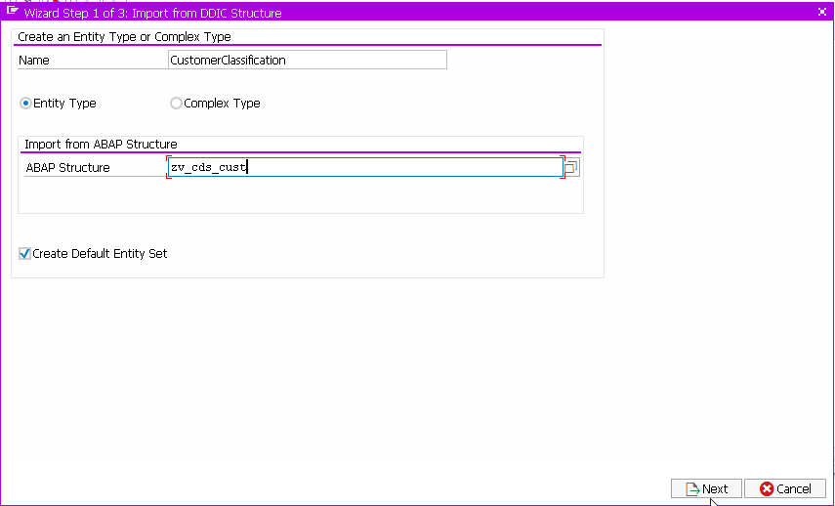

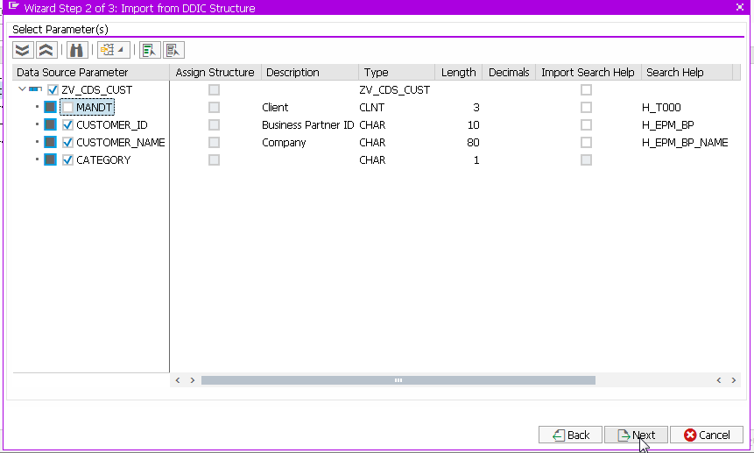

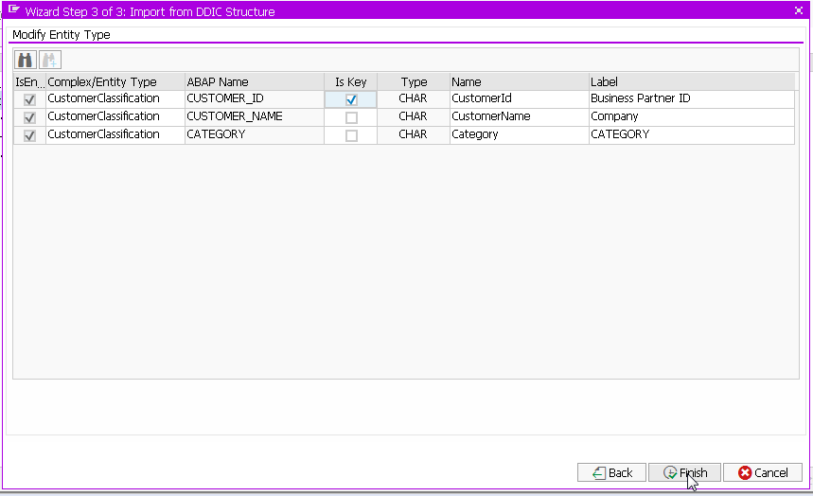

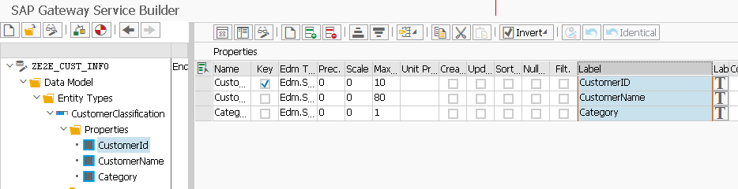

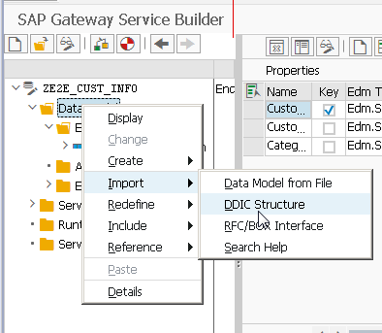

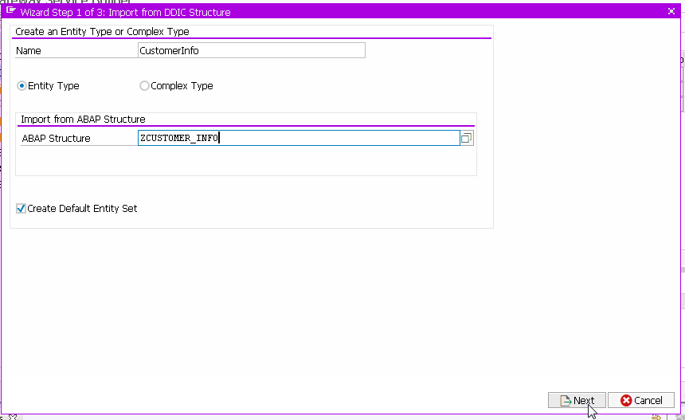

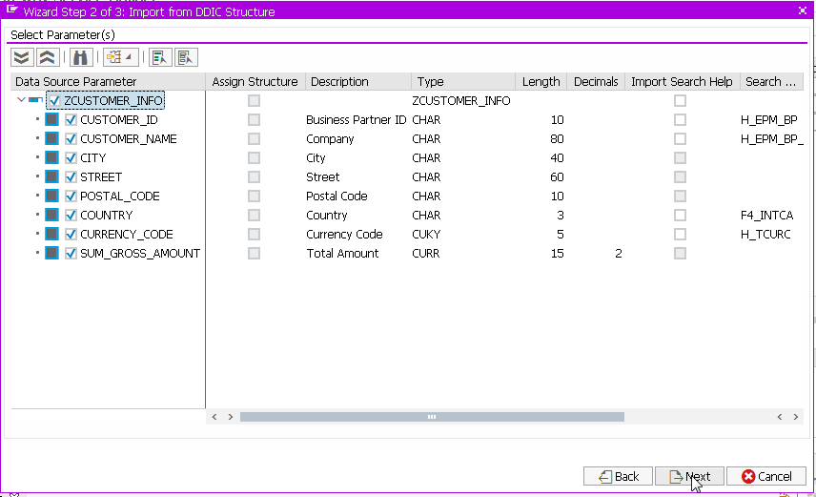

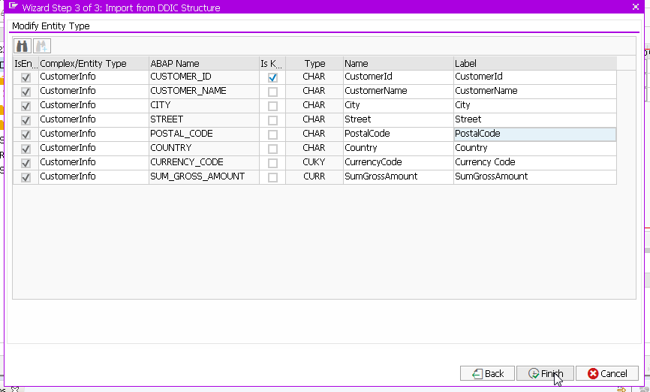

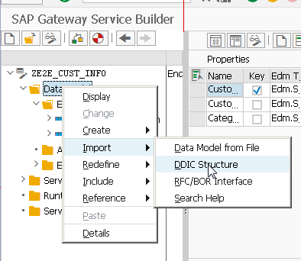

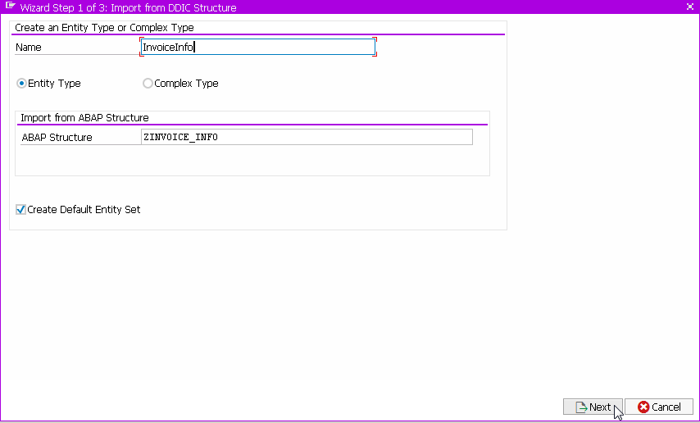

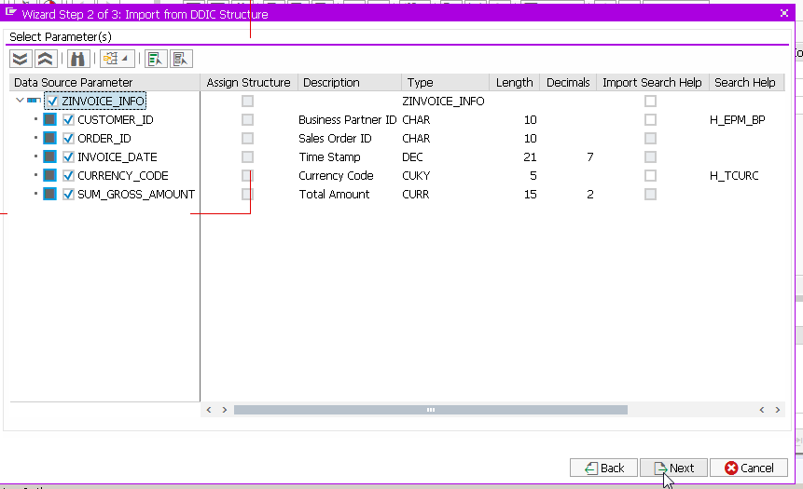

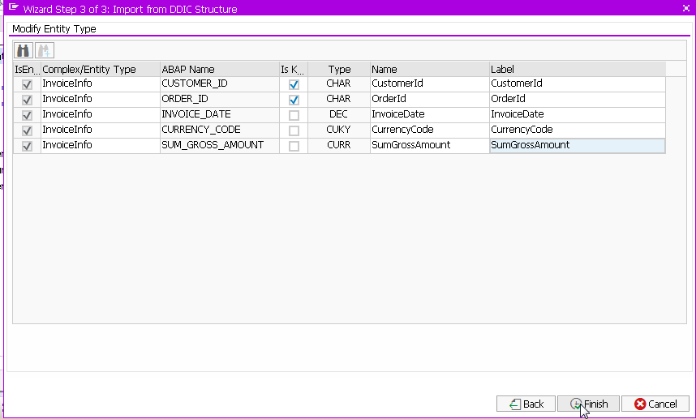

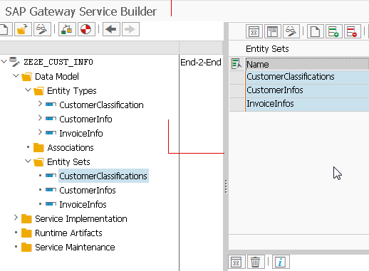

Define the relation between the entities by creating associations:

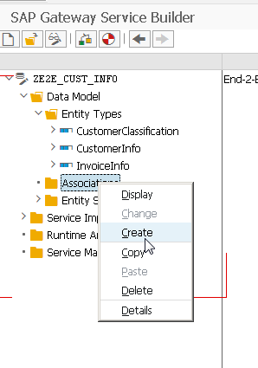

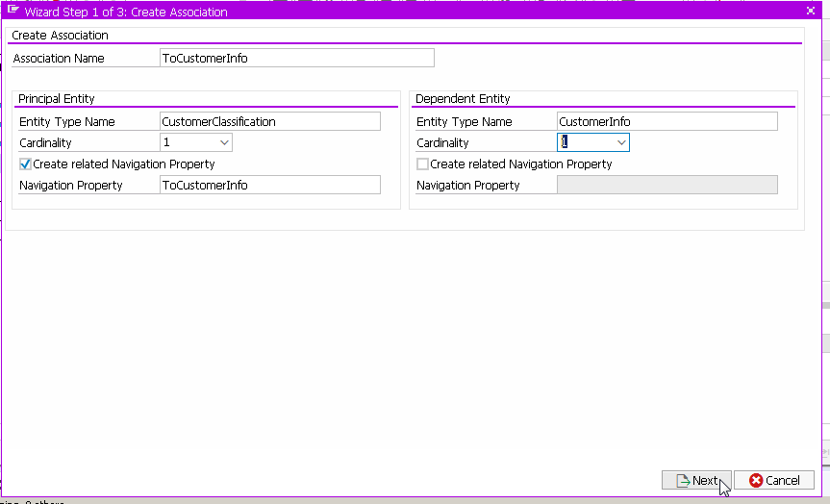

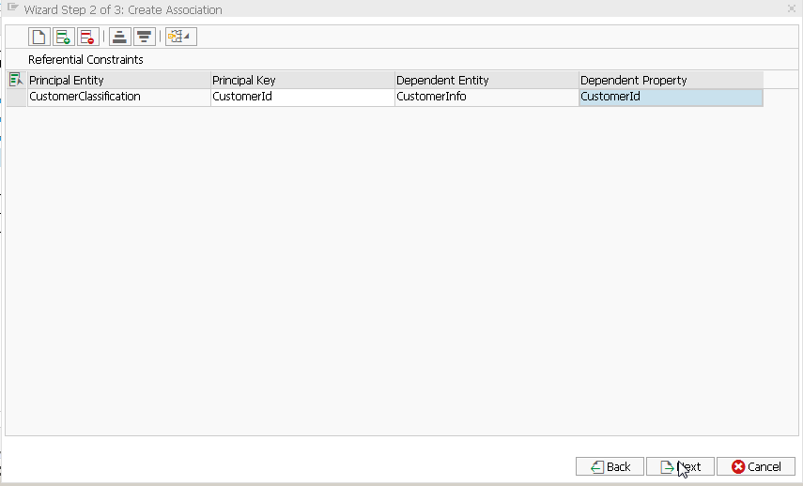

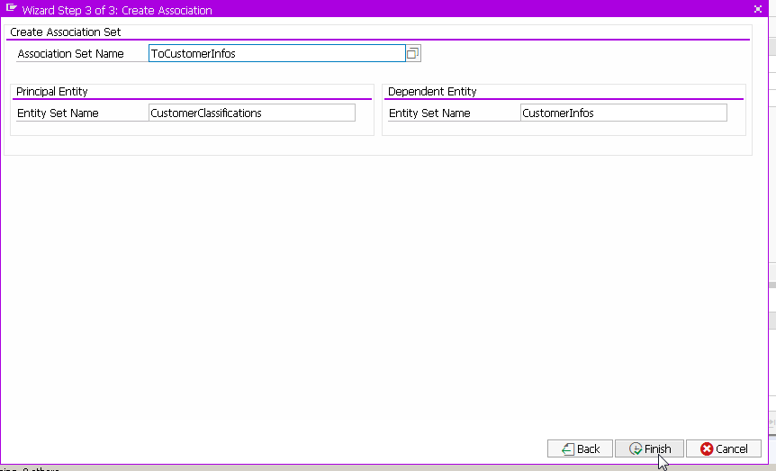

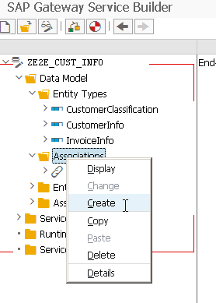

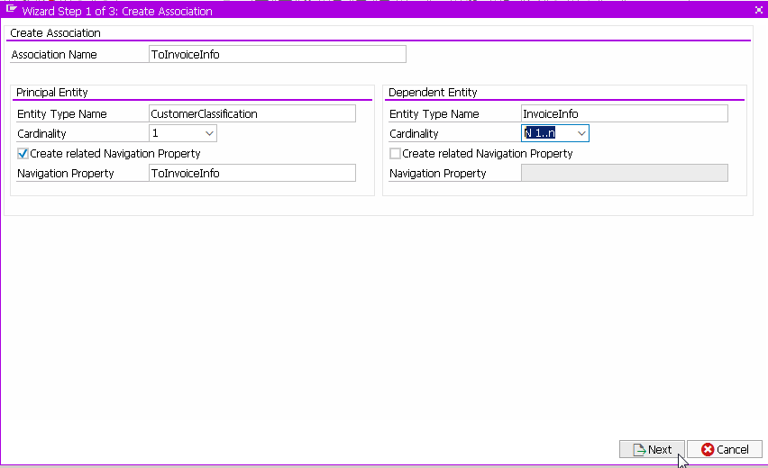

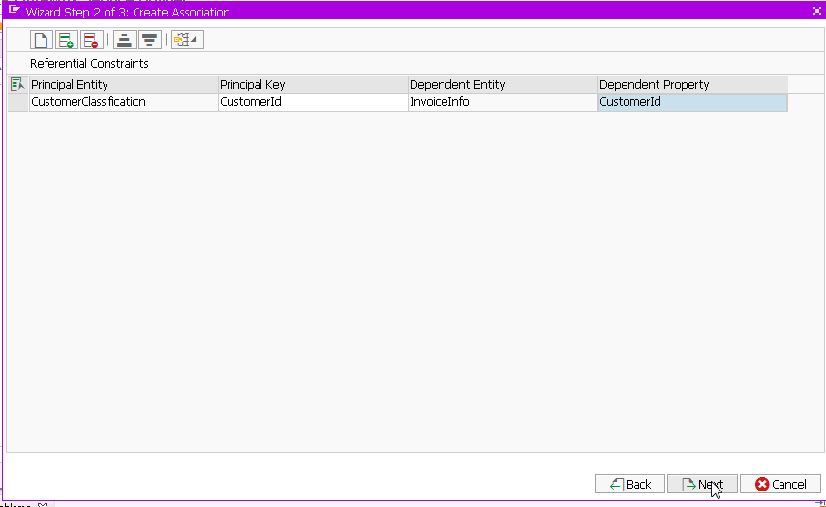

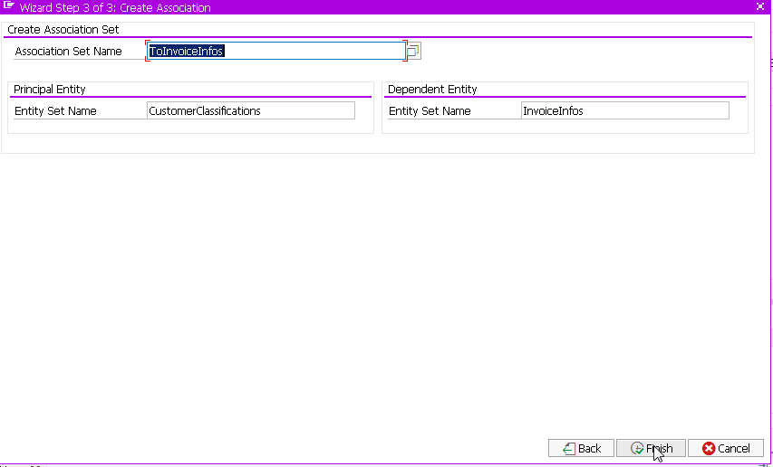

Save and Generate

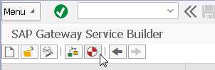

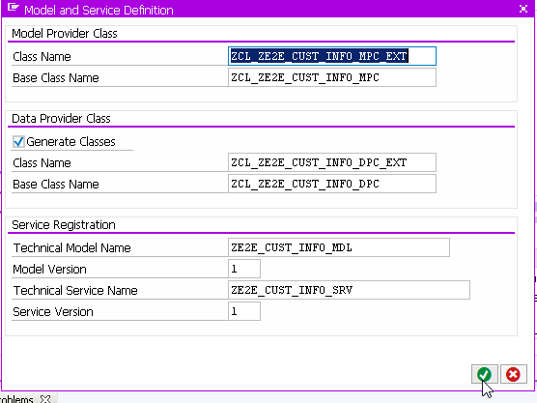

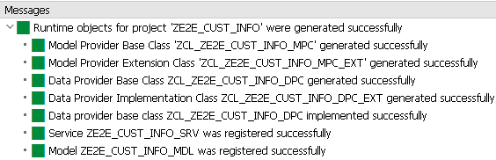

Re-open transaction and click to edit but first select the gateway service

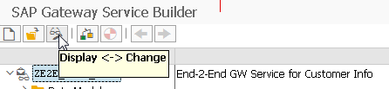

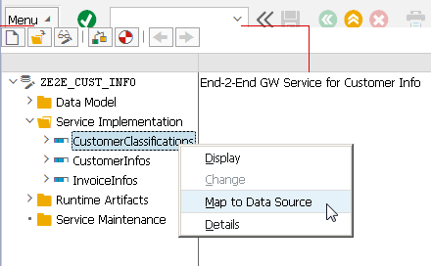

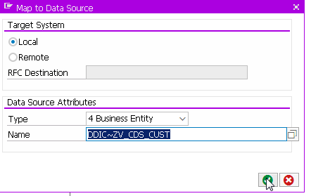

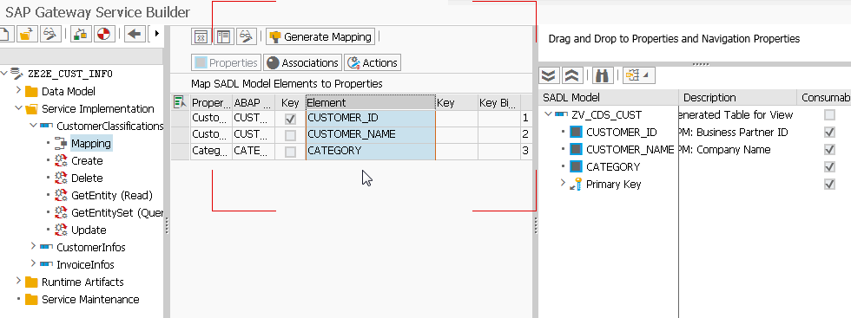

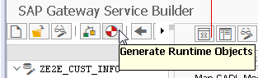

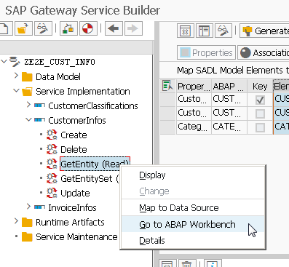

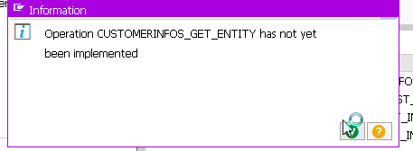

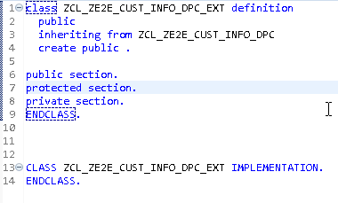

Use the quick fix to add the implementation of the methods automatically:

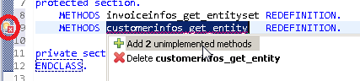

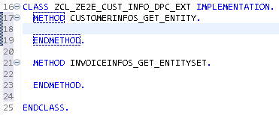

Code Snipet:

CLASS zcl_ze2e_cust_info_dpc_ext DEFINITION

PUBLIC

INHERITING FROM zcl_ze2e_cust_info_dpc

CREATE PUBLIC .

PUBLIC SECTION.

PROTECTED SECTION.

METHODS invoiceinfos_get_entityset REDEFINITION.

METHODS customerinfos_get_entity REDEFINITION.

PRIVATE SECTION.

ENDCLASS.

CLASS zcl_ze2e_cust_info_dpc_ext IMPLEMENTATION.

METHOD customerinfos_get_entity.

" Entity can only be accessed via the navigation property ToCustomerInfo

" of entity type CustomerClassification and if the key CustomerID is provided

IF iv_source_name <> zcl_ze2e_cust_info_mpc=>gc_customerclassification.

RAISE EXCEPTION TYPE /iwbep/cx_mgw_tech_exception.

ENDIF.

READ TABLE it_key_tab INTO DATA(ls_key) WITH KEY name = 'CustomerID'.

IF sy-subrc <> 0.

RAISE EXCEPTION TYPE /iwbep/cx_mgw_busi_exception

EXPORTING

textid = /iwbep/cx_mgw_busi_exception=>filter_not_supported.

ENDIF.

DATA: lv_customer_id_filter TYPE snwd_partner_id.

"Apply conversion of snwd_partner_id (domain D_EPM_ID)

CALL FUNCTION 'CONVERSION_EXIT_ALPHA_INPUT'

EXPORTING

input = ls_key-value

IMPORTING

output = lv_customer_id_filter.

"Create an instance of class zcl_customer_open_invoices

DATA(lo_cust_info) = NEW zcl_customer_open_invoices( ).

"Call the ABAP managed DB procedure respectively the

"ABAP class method get_customer_info

lo_cust_info->get_customer_info(

EXPORTING

iv_client = sy-mandt

iv_bupaid = lv_customer_id_filter

IMPORTING

et_bpinfo = DATA(lt_entity) ).

IF lines( lt_entity ) <> 1.

RAISE EXCEPTION TYPE /iwbep/cx_mgw_busi_exception

EXPORTING

message_unlimited = | Problem in Customer Info; { lines( lt_entity ) } <> 1 |

textid = /iwbep/cx_mgw_busi_exception=>business_error_unlimited.

ENDIF.

"map the first row of lt_entity to the output

er_entity = lt_entity[ 1 ].

ENDMETHOD.

METHOD invoiceinfos_get_entityset.

" Entity can only be accessed via the navigation property ToCustomerInfo

" of entity type CustomerClassification and if the key CustomerID is provided

IF iv_source_name <> zcl_ze2e_cust_info_mpc=>gc_customerclassification.

RAISE EXCEPTION TYPE /iwbep/cx_mgw_tech_exception.

ENDIF.

READ TABLE it_key_tab INTO DATA(ls_key) WITH KEY name = 'CustomerID'.

IF sy-subrc <> 0.

RAISE EXCEPTION TYPE /iwbep/cx_mgw_busi_exception

EXPORTING

textid = /iwbep/cx_mgw_busi_exception=>filter_not_supported.

ENDIF.

DATA: lv_customer_id_filter TYPE snwd_partner_id.

"Apply conversion of snwd_partner_id (domain D_EPM_ID)

CALL FUNCTION 'CONVERSION_EXIT_ALPHA_INPUT'

EXPORTING

input = ls_key-value

IMPORTING

output = lv_customer_id_filter.

"Create an instance of class zcl_customer_open_invoices

DATA(lo_cust_info) = NEW zcl_customer_open_invoices( ).

lo_cust_info->get_invoice_info(

EXPORTING

iv_client = sy-mandt

iv_bpaid = lv_customer_id_filter

IMPORTING

et_invinfo = DATA(lt_entityset) ).

"provide the resultset of the AMDP to the tabular

"tabular output parameter

et_entityset = lt_entityset.

ENDMETHOD.

ENDCLASS.

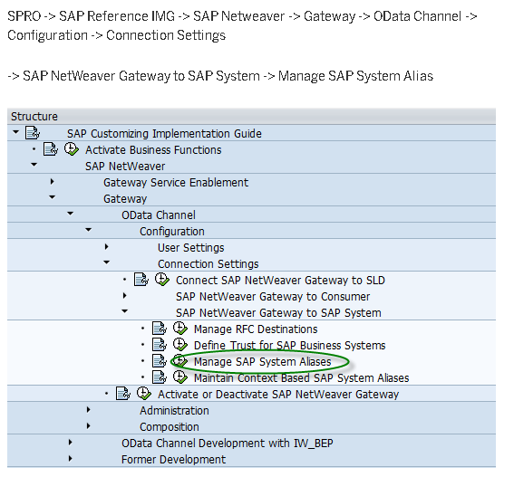

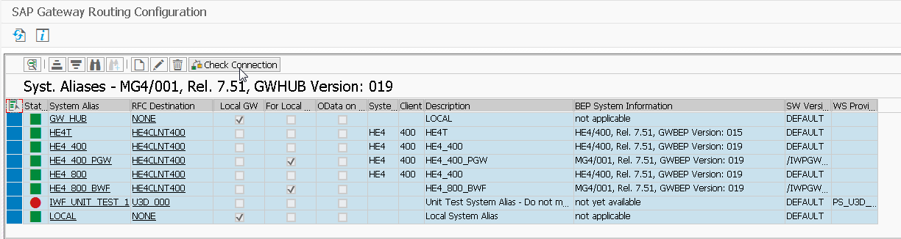

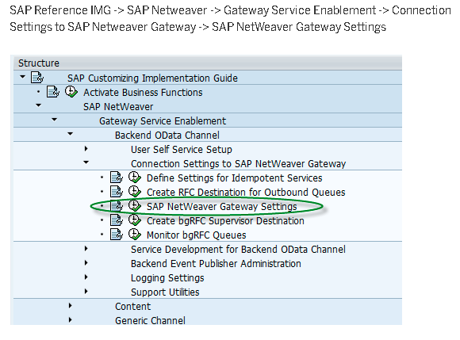

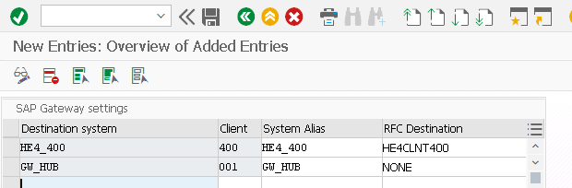

SEGW:

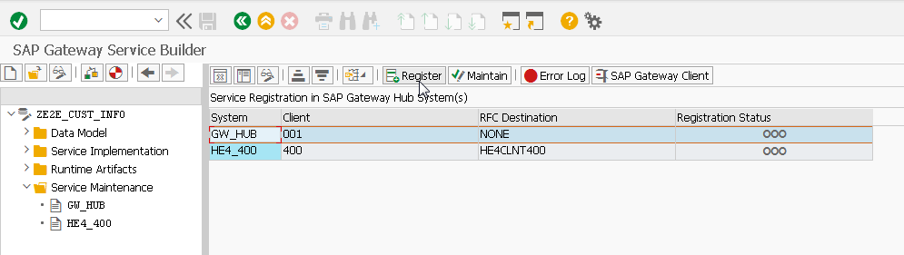

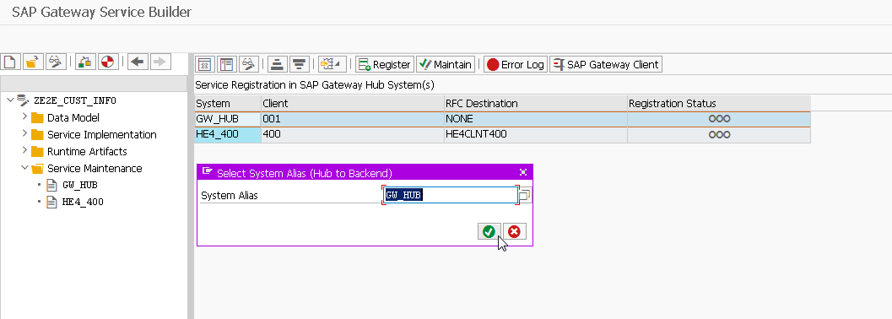

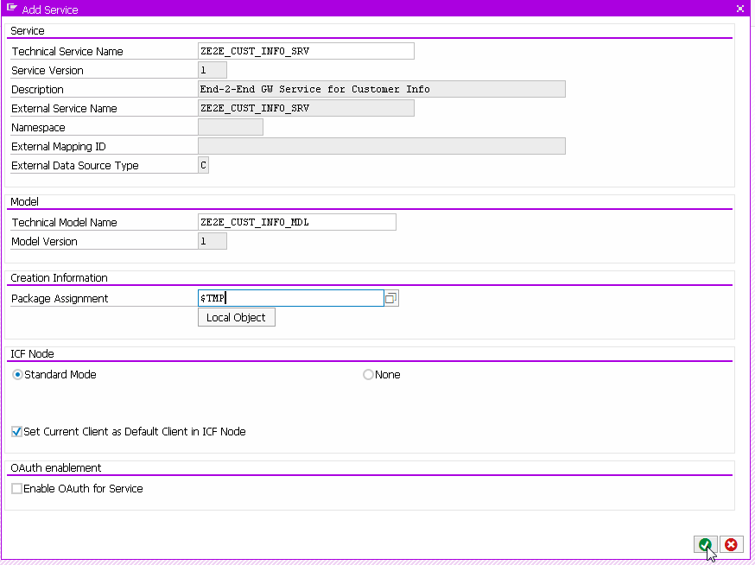

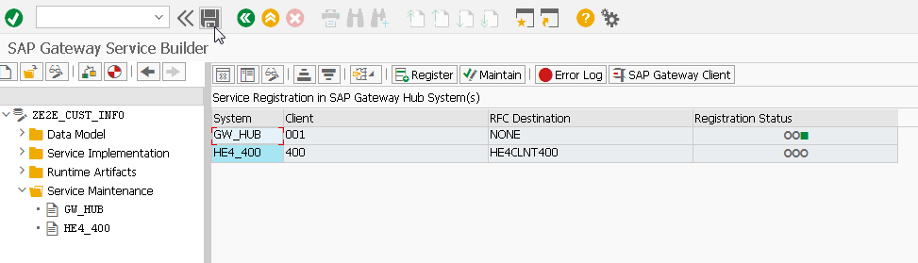

Testing the ODATA – Transaction /IWFND/GW_CLIENT:

